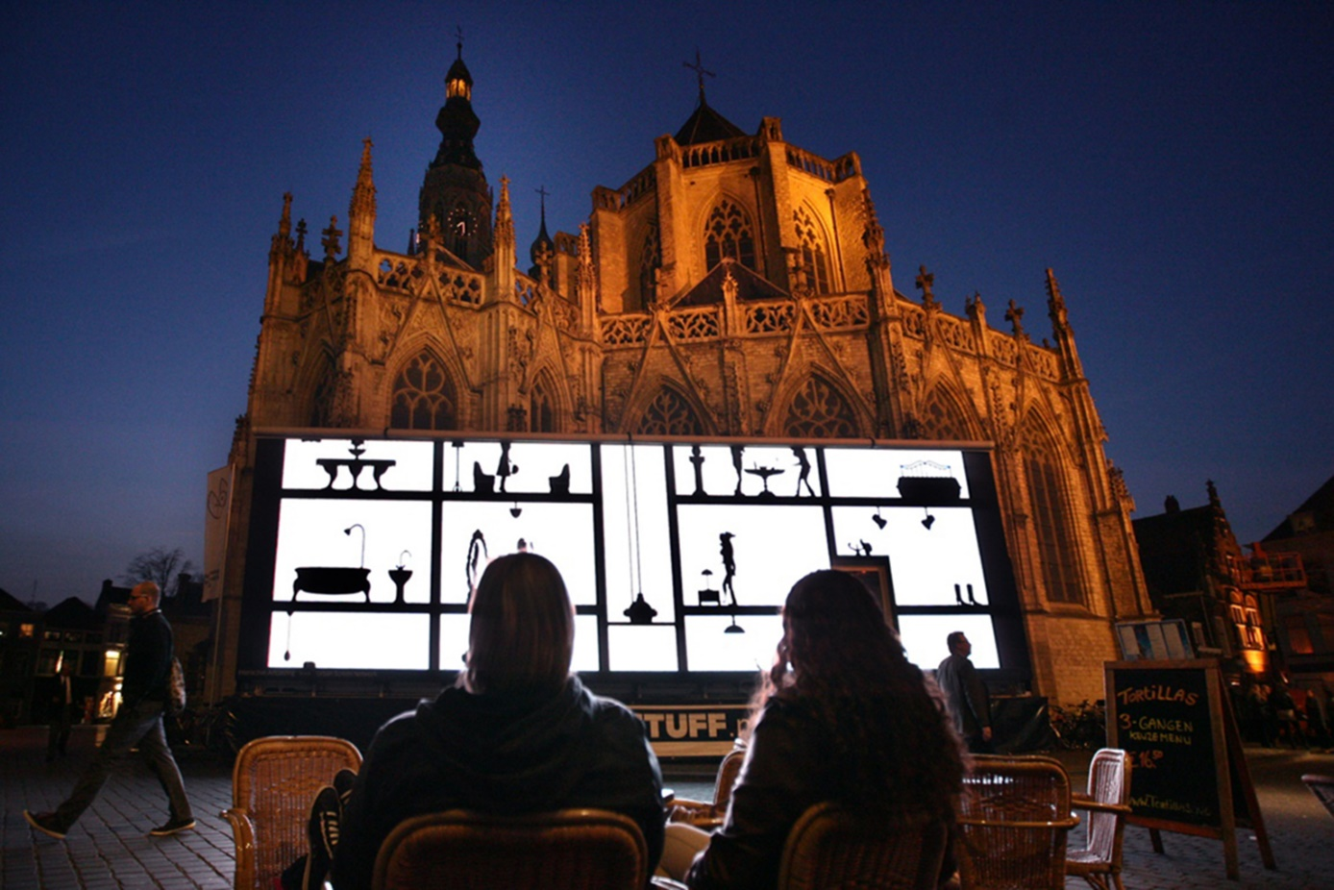
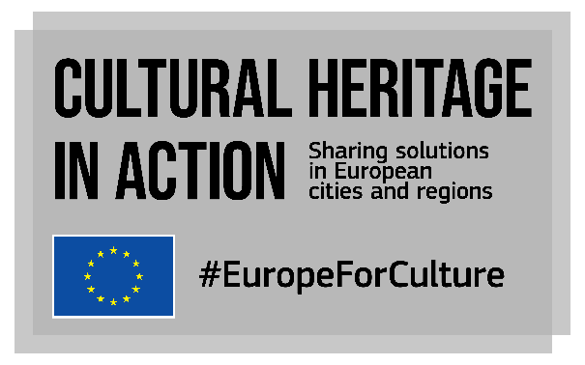
CALL FOR GOOD PRACTICES
Are you working on cultural heritagE for a city, region, non-urban or rural area?
SHARE YOUR GOOD PRACTICES!
Closing date: 27 March 2020

What is ‘Cultural Heritage in Action’?
Cultural Heritage in Action is one of the actions of the European Framework for Action on Cultural Heritage of the European Commission. It is a peer-learning programme that will allow over 100 local and regional policy makers to exchange knowledge on cultural heritage, with a focus on participatory governance, adaptive reuse and quality of interventions.
The project shall empower cities and regions to strengthen their cultural heritage policies and initiatives as well as develop innovative solutions to preserve cultural heritage assets.
Our consortium led by EUROCITIES with KEA, ERRIN, Europa Nostra and Architects’ Council of Europe leads the project funded by the European Union’s Creative Europe programme from January 2020 to April 2021.
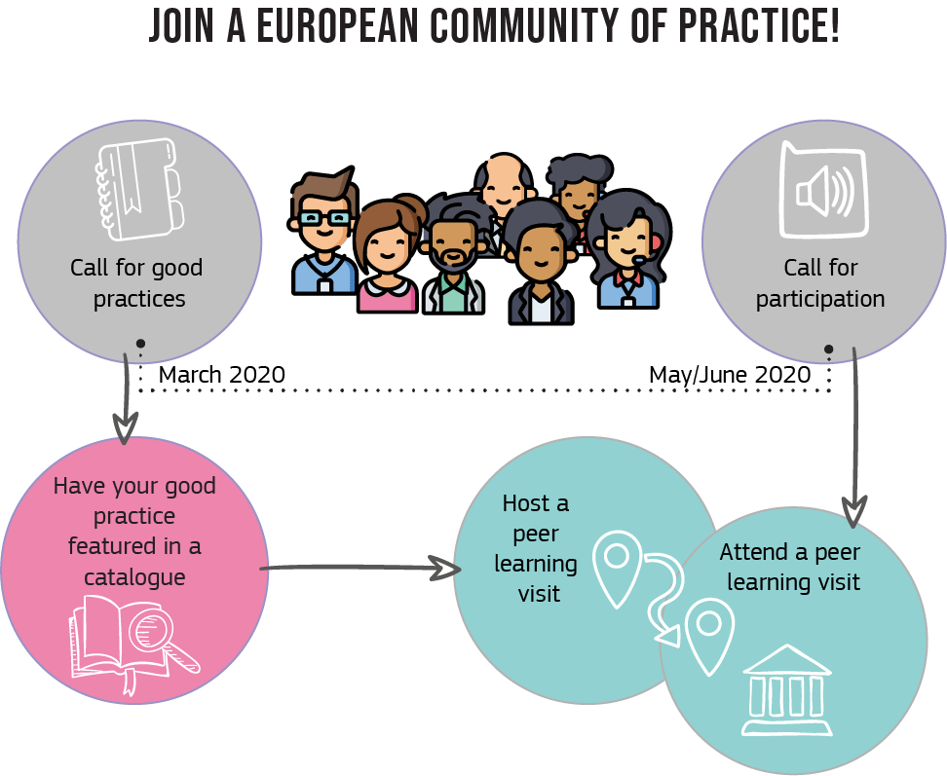

What will happen?
We will produce a catalogue of 30 good practices from EU cities, regions, urban, non-urban and rural areas and will organise 12 peer-learning visits bringing together 20+ participants per visit (an open call for participation will be launched in May/June 2020).

We are now looking for practices:
- that are innovative
- that are inspiring for other cities and regions
- that have a real impact on the ground

Practices can be policies, projects, events or organisational structures developed by local and regional authorities. They can be implemented by the authorities themselves or by other local stakeholders.
Is this call for me?
This call is open to local and regional administrations of all sizes (rural areas, medium size cities, large and capital cities, regions) from the 27 European Union countries. In some cases, the questionnaire can be filled in “on behalf of” a local/regional administration, for example by a university, an architect or a local/regional stakeholder; a written endorsement by a representative of the local/regional administration at the origin of the practice should then be provided.

Why should I submit a practice?
- to be featured in an online catalogue and visible at EU level
- to give a chance to my city/region to host a peer-learning visit
- to be part of a community of practice

Which themes should the practices relate to?
We consider cultural heritage as ‘resources inherited from the past in all forms and aspects – tangible, intangible and digital (born digital and digitized), including monuments, sites, landscapes, skills, practices, knowledge and expressions of human creativity, as well as collections conserved and managed by public and private bodies such as museums, libraries and archives’ (Council conclusions on cultural heritage as a strategic resource for a sustainable Europe, May 2014).

We are looking for practices that are linked to at least 1 of the 3 topics described below:
Participatory governance of cultural heritage  #EuropeForCulture | Participatory governance is about participatory and people-centred approaches that involve the public sector, private stakeholders and civil society to:  - co-design cultural heritage policies and programmes  - share management and safeguarding of cultural heritage  - increase the valorisation of cultural heritage in communities  - use cultural heritage as a resource for community and territorial development  For more information, please read the report of the Open Method of Coordination working group on this topic and the corresponding brainstorming report from the Voices of Culture process.
Adaptive re-use of heritage buildings  #EuropeForCulture | Adaptive re-use of heritage buildings is the act of giving a new use to an obsolete, underused or misused building.  In the adaptive reuse approach, rather than continuing the building’s existing use through upgrades or restoring it to a specific time period, the new use is defined and adapted to the building while preserving and respecting its value and significance.  For more information, please read the Leeuwarden declaration on adaptive re-use of built heritage.
Quality of interventions on cultural heritage  #EuropeForCulture | Interventions on cultural heritage might be risky: improper interventions can put heritage in danger. Quality interventions are essential if we want to bequeath our heritage to future generations – they are the outcome of multiple factors including aesthetics, habitability, environmental friendliness, accessibility, integration into the surrounding environment and affordability.  For more information, please read the European quality principles for EU-funded interventions with potential impact upon cultural heritage elaborated by ICOMOS (2019).

How will be practices be selected?
Our team of experts will use the following criteria:
- Strategic vision (is cultural heritage a priority in local/regional policies?)
- Relation to EU strategic documents (does the practice share common goals?)
- Impacts and results
- Potential for replicability
- Thematic balance between the 3 topics, geographical and spatial balance
Join our information webinar!
We will respond to all your questions during a webinar on Friday 6 March from 10:00 to 11:00 (Brussels time). To join, make sure your computer has a working audio/video device and register here!

Please fill in the call below by 27 March 2020 and return it to culturalheritageinaction@eurocities.eu

Tell us about your good practice
Please write in a clear and concise manner, keeping in mind that the reader is not familiar with your local context. Should your practice be selected, we will come back to you in April.

The local context
- Profile of the city/region
Name of the city/region:
Country:
Structure:
☐ | town
☐ | city
☐ | metropolitan area
☐ | region
☐ | other (including cross-border cooperation) - please specify
Number of inhabitants:
- Are culture and cultural heritage identified as a priority at the local/regional level? Are they integrated in local or regional development plans? Please refer to the main policy documents or instruments and elaborate on the most relevant content
- Are culture and cultural heritage connected to other policy areas at local/regional level? (please explain and provide examples)

Description of the practice
Title:
Objective(s) of the practices. Was it developed to tackle specific challenges? Which ones?
Main topic(s) covered:
☐ |  | Participatory governance of cultural heritage
☐ |  | Adaptive re-use of heritage buildings
☐ |  | Quality of interventions on cultural heritage
Themes covered by the practice (you can tick several boxes)
Type of heritage covered by the practice: |  |  |  |  | Type of policies covered in the practice:
☐ | Tangible heritage |  |  |  | ☐ | Environment/sustainability
☐ | Intangible heritage |  |  |  | ☐ | Circular economy
☐ | Digital heritage |  |  |  | ☐ | Participatory governance
☐ | Listed heritage |  |  |  | ☐ | Non-financial support (training, use of space, technical assistance etc.)
☐ | Non-listed heritage |  |  |  | ☐ | Innovative forms of financing
☐ | Buildings |  |  |  | ☐ | New business models, products, services
☐ | Contemporary architectural heritage (post WWII) |  |  |  | ☐ | Social cohesion
☐ | Historical sites |  |  |  | ☐ | Tourism
☐ | Monuments |  |  |  | ☐ | Cross-sectorial collaboration
☐ | Industrial sites |  |  |  | ☐ | Urban, regional regeneration
☐ | Religious sites |  |  |  | ☐ | Employment and entrepreneurship
☐ | Natural heritage |  |  |  | ☐ | Other, please specify
☐ | Skills
☐ | Folklore
☐ | Gastronomy
☐ | Museums
☐ | Libraries
☐ | Archives
Date and duration of the practice:
Stage of implementation:
☐ | Implementation
☐ | Evaluation/Review
☐ | Project finished
Target beneficiaries:

- Please describe the practice. Be sure you refer to the practical implementation, the strategy adopted, and the challenges encountered and solutions to overcome them (max 500 words)

Management
Human resources
- Who oversaw the implementation of the practice inside the local/regional administration (departments, services), or in other organisations?
- How many staff members are/were needed to develop the initiative? How many staff are working to sustain it?

Were partners/stakeholders involved? If yes, which ones?
Budget:
- Total budget of the initiative:
- How was the budget allocated?
Funding sources (please specify percentages):
☐ | Municipality | %
☐ | Region | %
☐ | National administration | %
☐ | EU | %
Indicate which EU fund/programme:
☐ | Private investor/sponsor | %
☐ | Other (please specify type) | %

Evaluation and impacts
- How has the practice been evaluated? Is a report available? If yes, what are the main conclusions or recommendations? Please feel free to attach it.
- Please provide any indicators/data you may have, both quantitative (figures) and qualitative (such as personal stories or testimonials, spill-over effects in other sectors, etc.). Max. 500 words
- Will the initiative be continued or expanded in your city/region or beyond?

Transferability to other local/regional contexts
- Why do you think this initiative could be considered as a good source of inspiration for other European cities/regions?
- If you had 3 recommendations for a colleague from another city/region willing to develop a similar initiative, what would these be?

Photos
Please provide up to 10 good quality photos (JPEG), including captions. The photos should clearly reflect the spirit of the initiative and should be used to illustrate its aspects.

Links
Please add links to websites, reports, social media, video etc.

Hosting a peer-learning visit

an early and NON-BINDING expression of interest
We will organise 12 peer-learning visits in cities/regions featured in the catalogue of good practices.
What are peer-learning visits?
Peer-learning visits are an opportunity for experts, decision makers and stakeholders to visit another city/region and see first-hand how it has successfully implemented policies and projects. Visits will take place between September 2020 and April 2021 and will be organised by host cities/regions in cooperation with EUROCITIES and experts working with us. Each visit will be attended by 20+ participants who will be selected through a call for interest.
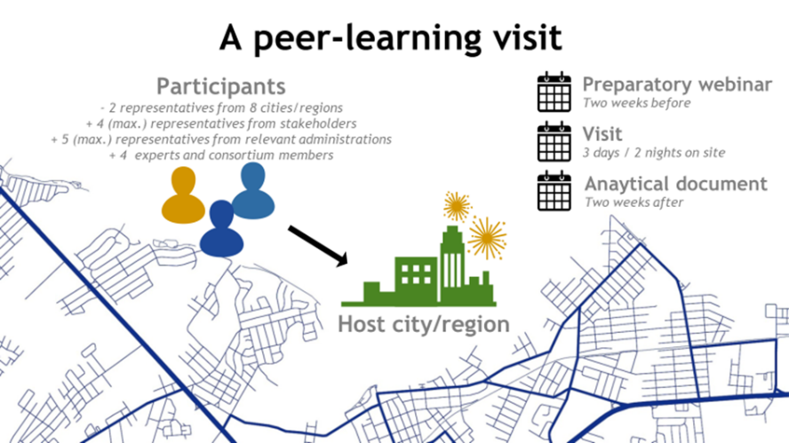
Why hosting a peer-learning visit?
Hosting a visit is just as beneficial as joining a visit!
- to benefit from the experience of visitors
- to gain a reputation for being an international frontrunner
- to foster work with your local partners
Format of the peer-learning visits
Each visit will last 3 days and 2 nights and will combine meetings with local stakeholders, visits and solution-building workshops. The working language will be English.
What does hosting a visit mean for my city/region? What will I be expected to do?
The host city/region will:
- Appoint a local contact person
- Liaise with the consortium to agree on the objectives of the visits
- develop an agenda for whole duration of the visit, in cooperation with our consortium
- Provide documentation on the practices implemented locally
What are the costs for my city/region?
Costs are basically human resources from your city/regions that are necessary to prepare the visit. Our hosts are also expected to provide meeting rooms. The project will cover travel and accommodation costs for visitors, as well as lunches and dinners (our consortium will take care of all logistical aspects).
Based on the information above, and if my practice is featured in the catalogue, my city/region:
☐ is potentially interested in hosting a peer-learning visit
☐ is not interested in hosting a peer-learning visit
Please note that this is only an early expression of interest. In April, we will contact the cities/regions featured in the catalogue of good practices and will ask them to officially apply to host a visit.
Contact persons for your local/regional practice
Person in charge of the presented practice
Name (title - first name - last name):
Position:
Organisation:
Email:
Telephone (incl. country code):
Mobile phone (incl. country code):
Website:
Email address:
Person to contact for more information on the presented practice (If different)
Name (title - first name - last name):
Position:
Organisation:
Email:
Telephone (incl. country code):
Mobile phone (incl. country code):
Website:
Email address:
How did you find out about this call?
Would you like to receive future Cultural Heritage in Action electronic newsletters?
General Data Protection Regulation: please find all useful information here.

Please send this completed questionnaire to culturalheritageinaction@eurocities.eu
Thank you very much for responding to this call. We will come back to you in April 2020.
Any question? Contact us culturalheritageinaction@eurocities.eu

For instance, the New European Agenda for Culture or the European Framework for Action on Cultural Heritage.

